**A Review Paper**

**On**

**Student Result Management System (SRMS)**

**Anubhav Thapa Dhruv Jain**

**Abhishek Kumar**

**Vandana Bansal (Guide)**

**Abstract:**

Student Result Management System is a web-based application which was developed to maintain the results of the students. In this application, PHP is the server-side language, MySQL and PHP is used as back-end design and HTML, CSS and JavaScript are used as front-end tools. The project aims to automate semester result management of VNSTIW since it is a computerized examination results management system for tertiary student's examination records. It will simplify and speed up the result preparation, management process, and duties like a tool for reducing the manual work, dispense us with maximum optimization that holds up both students and administration authorities to access the results. The project intends to provide the examination result to the student in a simple way. It is functional for students and institutions to come into possession of the results in a simple manner. Being a result analyzer displaying subject status and grades helps students look at the results. The system meant for students with privileges given to students are to read and execute their results by furnishing user names and passwords for secure login. In the case of a new student, the registration system is ready for use, and the guest user has the privilege only to read.

**Introduction**

A Student Result Management System (SRMS) is a software program that tracks, maintains, and manages all of the data created by a school or college or any institute such as a student's grades, results, attendance and also interpersonal activity records among other things.

Universities and institutes that embrace information and communication technologies use it to transform their record-keeping and information-management processes. Students result management system (RMS), in particular, is one of the important information systems that most universities are interested in. While universities in rich nations have well-established student result management systems, their equivalents in underdeveloped countries have a patchwork of ad hoc and standalone systems that only cover the most basic features of a student result management system. Similarly, the majority of student RMSs lack web interfaces and do not interact properly with other university-wide information systems. The main issue is that institutions outsource the creation of such RMS without first gaining a thorough understanding of the requirements.

**Context Diagram**

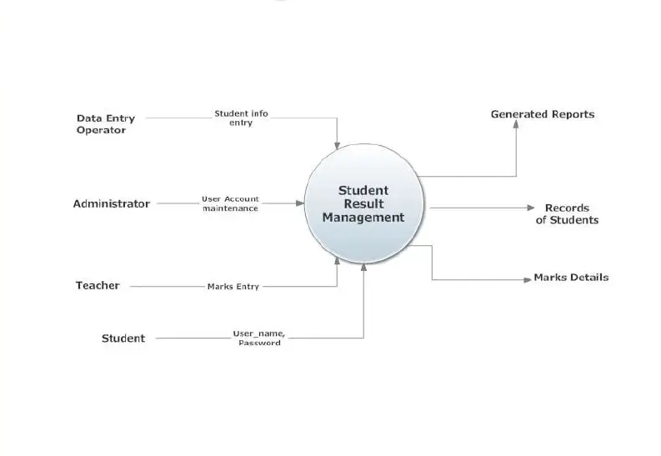

**Use case Diagram**

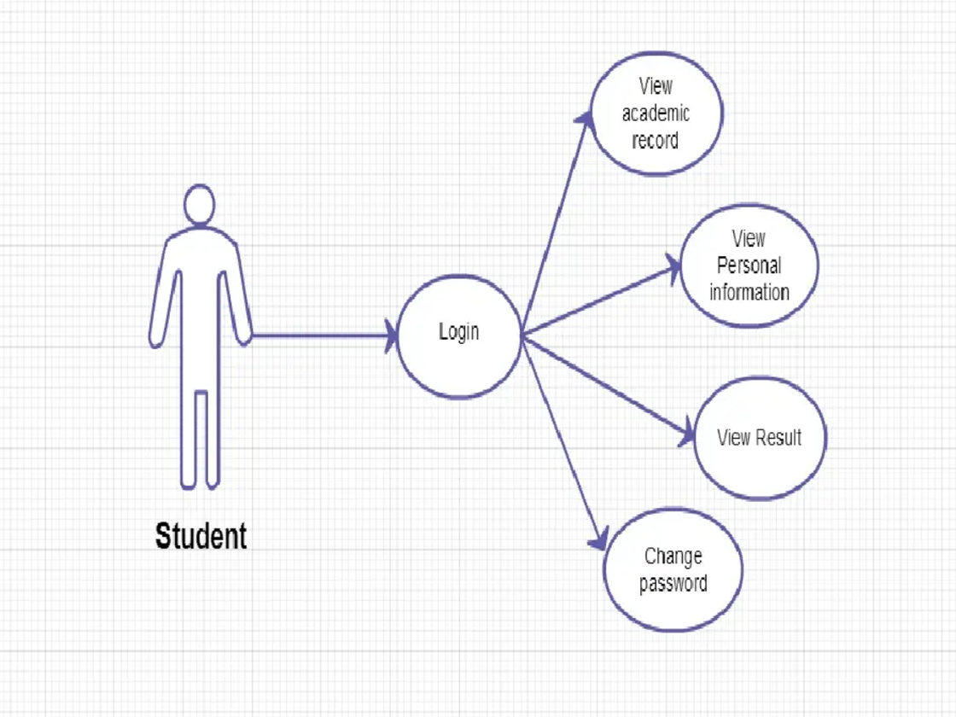

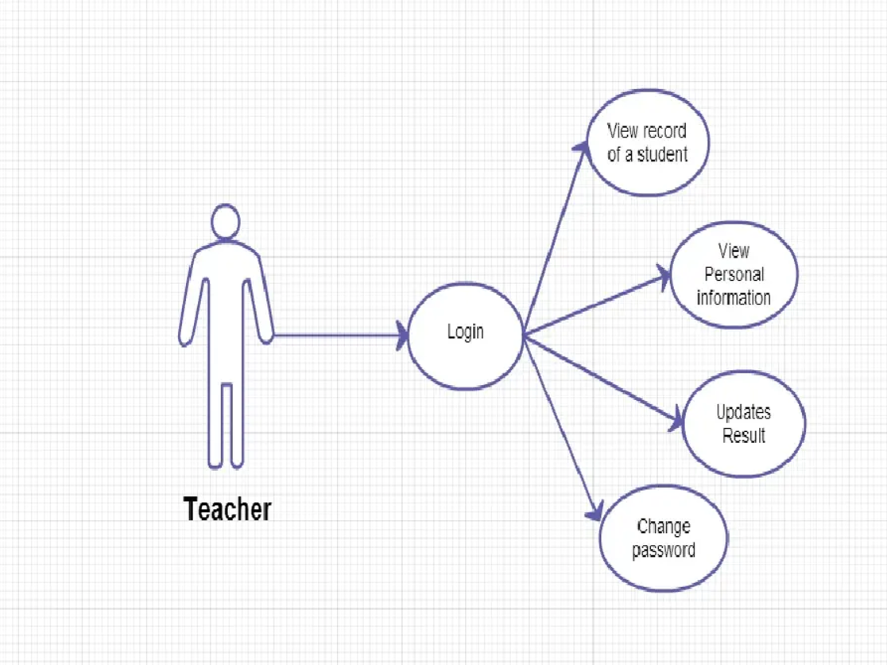

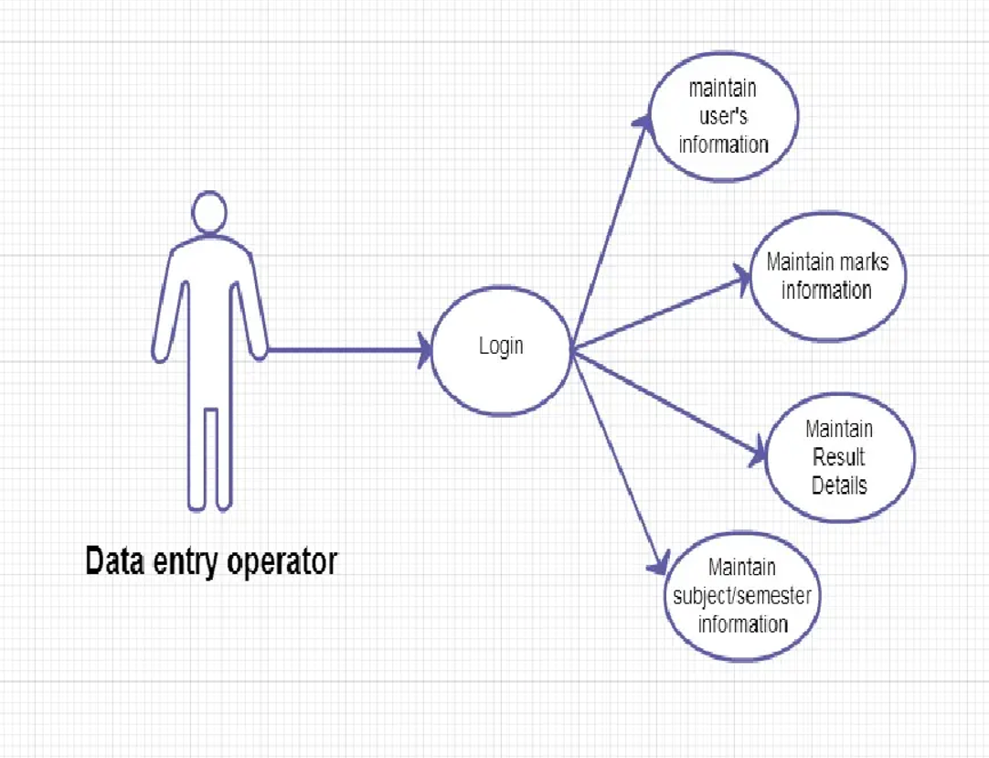

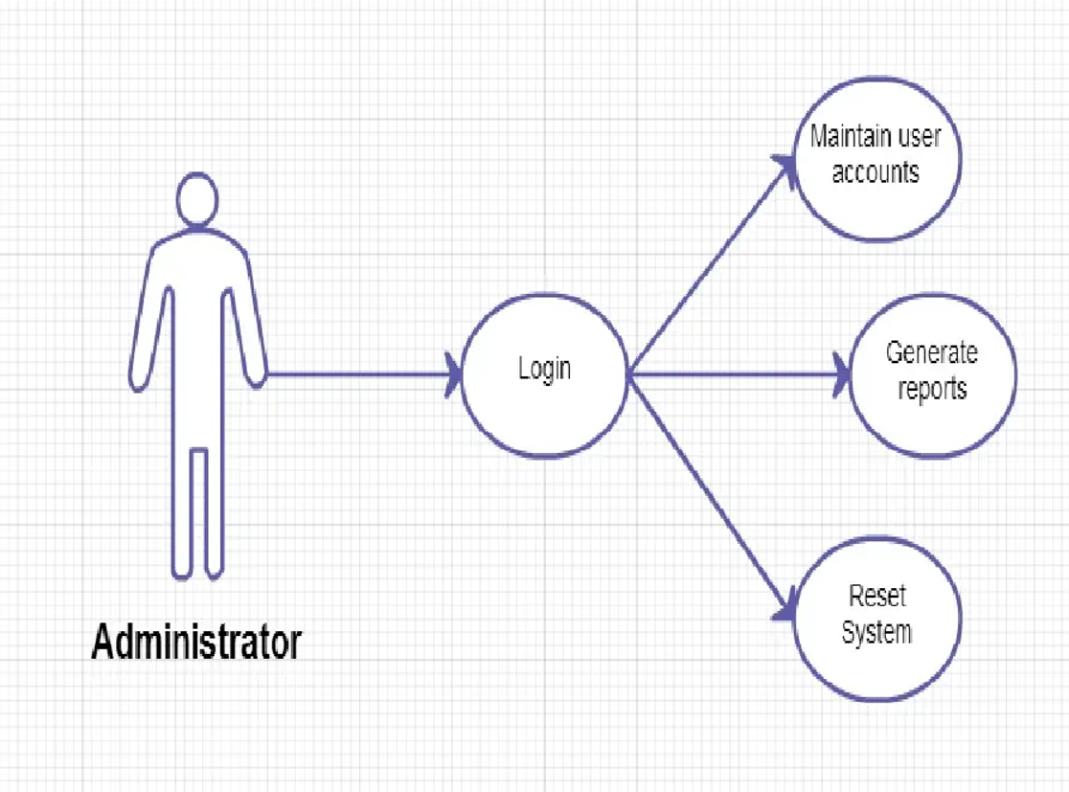

**Usercase Diagram**

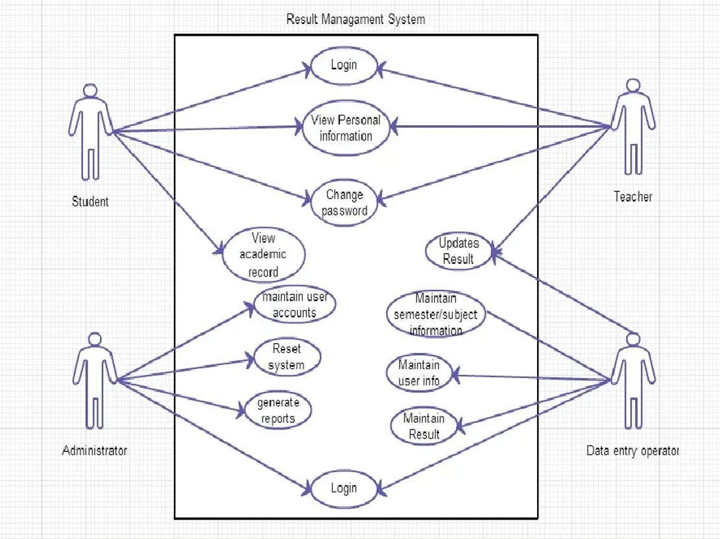

In Catholicism, the mechanism of announcing and tracking student outcomes is currently in place.

The findings of the students are generated using a spreadsheet programme, then printed on paper, put on the wall as a proclamation, and kept.

It doesn't function very well until you have a system that provides results.

The system takes time and requires human resources to do numerous activities, is costly, and lacks data security and efficiency. And the centre currently need an improved,

computer-assisted environment. And, once implemented, it will solve all of the aforementioned issues.

**Problem Definition**

Universities and institutes that embrace information and communication technologies use it to transform their record-keeping and information-management processes. Students result management system (RMS), in particular, is one of the important information systems that most universities are interested in. While universities in rich nations have well-established student result management systems, their equivalents in underdeveloped countries have a patchwork of ad hoc and standalone systems that only cover the most basic features of a student result management system. Similarly, the majority of student RMSs lack web interfaces and do not interact properly with other university-wide information systems. The main issue is that institutions outsource the creation of such RMS without first gaining a thorough understanding of the requirements. Universities and institutes that embrace information and communication technologies use it to transform their record-keeping and information-management processes. Students result management system (RMS), in particular, is one of the important information systems that most universities are interested in. While universities in rich nations have well-established student result management systems, their equivalents in underdeveloped countries have a patchwork of ad hoc and standalone systems that only cover the most basic features of a student result management system. Similarly, the majority of student RMSs lack web interfaces and do not interact properly with other university-wide information systems. The main issue is that institutions outsource the creation of such RMS without first gaining a thorough understanding of the requirements.

**Width (scope)**

The study's goal is to build and deploy a web-based student outcome management system for the Catholic University of Mozambique, which will replace the old manually done paper work while also reducing security concerns and challenges. The proposed system is a multi-user system built with the Java programming language and Apache Tomcat Server, as well as support for MySQL DBMS (Database Management System). The system is exclusive to and designed for students. They have the ability to check their findings after being given a unique username and password for a secure login. A system administrator oversees the entire system and has complete authority over it, including the ability to read, write, and execute results as well as assign privileges to teachers and students. The teachers, too.

**The Importance of Research**

The computerization of the current system will have an impact on how students achieve their results, and how they are managed and executed by the staff of the institution. This system will make life easier for the facility as we will be able to store data much better than we were able to do before. Students will have a smart control of their results and will be able to track their progress easily, anywhere, anytime with any device connected to the Internet, and simply enter their pieces provided by the institution. Not only for the students, but also for the teachers and staff of the program administration. The data can be organized and secure as per their need. The system will allow teachers to organize students even at home, then do grade calculations automatically, and students can easily access and print them. This prevents teachers from doing all the work themselves, and having a better work ethic and management that can reduce time, human effort and mistakes.

**Working of SRMS:**

Student Result Management System is required by any educational institution that conducts examinations.

In this system, students may observe the outcome. With the use of the student roll number, it's quite easy to reveal the results to students after the training and exam. For colleges management system also, this application can be used.

**SRMS Modules:**

Students: You can add student information, such as fields (Student Name, Roll No, Email ID, Gender, Class, and DOB

Student Groups: This module allows you to simply construct a class using the section option. You may also manage all of the classes and the section.

Subjects: If you want to construct a subject, you can use the topic code. A really simple way to keep track of the subjects. You can also easily assign the subject to the class.

Result: The Result Section is a censorious or crucial or critical component of the application. You must first select the class, then the student's name, after which you will see the topics, after which you must simply enter the marks in the subject areas.

**Admin Level Features**

**Change password:** Admin are eligible for the password manipulation at anywhere and anytime.

**Dashboard:** Admin can see the total Subjects, Registered Users, Classes and Results on Dashboard.

**Full Screen:** It facilitates the full-screen mode property to view the Dashboard.

**Responsive:** Due to the use of bootstrap the application is very responsive and can be loaded in any compatible device i.e laptop, desktop, tablet, phone.

**Search Result Option for Students**

The option of Search Result is present on the root section. Students can be able to find their result by entering their roll number and a class option. On generating the click event on clicking the search button the result of the respected student will show on the screen. It also provides an option to print the result.

Installation

1. First download the zip file

2. Then extract the zip file that you have downloaded

3. Then open the PHPMyAdmin

4. Now you have to import the database srms.sql

5. After that click on the go button

6. Now type the localhost in your browser installed in your system

7. Finally, open SRMS

8. Now for Admin sign in at the right of the page filling the username and password.

**Advantages of SRMS:**

Administration Level:

**1.With a student management system, teachers, professors, and staff can create feedback analysis reports.**

**2.Grade book management.**

**3.Test Time Management.**

**4.Records marks and results on one website.**

**4.Add and manage students and Announce Results.**

**5.Assign seats to students in exam halls.**

**6.Integration-managing finances.**

**7.Create tests and tests online.**

**8.Introduce a single platform to deal with the preparation of all test records within the organization.**

**9.Generate test prints and quick test reports.**

**10.Post / publish results for parents and students online.**

**11.Record and search for details of all test student-wise.**

**12.Welcome Card / Hall Ticket Generation.**

**13.Calculate scores, percentages and marks.**

**14.Generate the debarred list of students on the basis of attendance.**

**For students:**

**1. Download results report in PDF format.**

**2. View test results and tests online.**

**3. Search for test and test points with a valid number / ID.**

**4. View Semester Results for all Lessons from anywhere using smart devices.**

**5. View the debarred list for the eligibility of individuals in every subject on the basis of attendance.**

**6. Application for review.**

**Disadvantage of SRMS:**

**1. Hackers are prone to gaining access to the student result management system.**

**2. After the deadline, the administration is unable to update or modify scores.**

**3. The application's extensive modules and features make it tough for a user to use it.**

**4. Minor technological hiccups and problems.**

**References:**

**1.** [(PDF) Student Result Management System | alka dubey - Academia.edu](https://www.academia.edu/36234156/Student_Result_Management_System)

**2.**